Economics of Elections

This month’s column, done in tandem with the article on elections done in the sister blog Aristotle2Digital, is about how voters choose how to spend their vote and how politicians choose to sell their services – in short, the economics of elections. The companion piece, entitled Election Conundrums, explored a particular case study, lifted from American politics, that illustrated Arrow’s Impossibility Theorem that states that it is impossible to find a voting system that guarantees a ‘fair’ outcome when three or more candidates are present. This conundrum is the result of the mathematical ambiguities found statistically summarizing the results of an election in which voters split their vote amongst those running for office. Being mathematical, that analysis did not try to determine how the voter population became split – it simply took the possibility and determined the implications.
This column remedies that deficiency by exploring some of the behavioral economics that lead to unusual electoral outcomes. The ideas discussed here are strongly influenced by the excellent video Why Government Fails by Antony Davies of Duquesne University.
Davies opens by dividing the US population into three categories: voters, politicians, and bureaucrats. He then goes on to speak about the myths that most people have about how government should work, myths based on naïve idealizations. He proceeds to demolish these myths by simply modeling the behavior of each member of those three strata in terms that a public choice economist would use to describe them: each of them are human beings subject to limitations (economic scarcity) and the desire to maximize his individual utility. By taking these attributes into account and by properly identifying the specific type of utility each wishes to maximize, Davies shows that the rational choices each member would make leads to a set of governmental behaviors quite different than what our idealism thinks should result.
For example, consider the following ‘stupid’ law: a member of the red population proposes a law in which each member of the green population pays ten dollars to the government, half of the money is incinerated, and the remaining money is then evenly distributed to the red population.
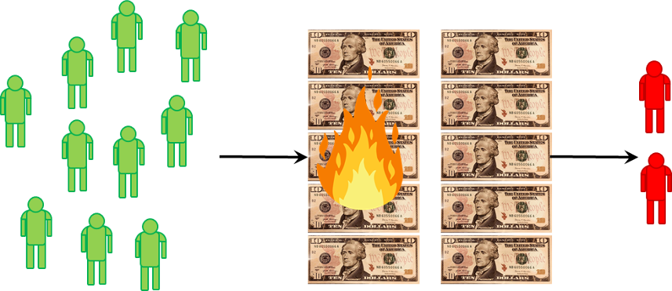
Most of us believe that since the green population outnumbers the red by a ratio of 5 to 1, this law, which is clearly societally bad, would never pass. But such analysis is naïve because it fails to account for the fact that voting entails a cost. Most of us are conditioned to be appalled by the thought of poll tax but in fact each of us bears such a cost when we vote. Even if money is not explicitly spent, there are costs associated with taking the time to learn about the issues, then to familiarize ourselves with the law, and finally to take the time and expend the effort to go to the polling place.
If we assign $20 as a monetary proxy for the cost (after all money is a proxy for time) then it in the rational best interest of each member of the green population to not bother getting involved but to simply bear the $10 cost as he will come out ahead. In a sense, each member of the green population knows how to pick his battle and this isn’t it. Davies says that the members of the green population are rationally ignorant of this kind of scenario where the cost is distributed and the benefit is concentrated. A real life example of such a perverse situation where the majority bear a cost that is less annoying than the effort to end it is found in the tariffs impose on sugar imports to the US.
Davies also gives excellent examples of how the concept of representative government can fall flat and how bureaucrats have an incentive to transform their jobs into something that works for them rather than a calling in which they work for someone else. But the scenario that is most interesting is the one involving politicians.
For simplicity, this analysis will be confined to two candidates, each vying for the largest number of votes between a polarized population made up of red and blue populations with very few members occupying the gray area of the middle ground.
Such a highly polarized voting population is quite familiar is these days of tribal politics and so one might think that the politicians elected into office are in fact hyperpartisan. But there is, in fact a tendency for candidates to rush to the middle, even though most voters sit somewhere else on the political spectrum.
The process could work something like this. Consider a population fiercely divided on welfare spending.
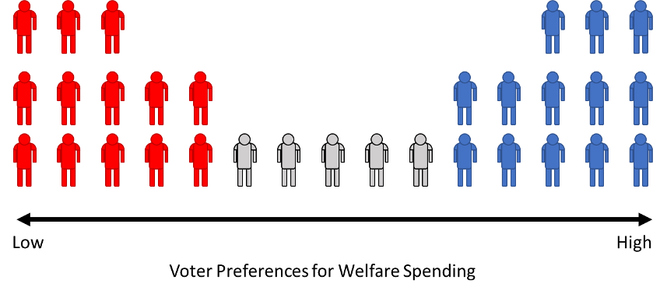
Candidate A favors a lower amount of governmental welfare support that Candidate B. As a result Candidate A is favored only the population with the box. Candidate B is considered better than Candidate A by the rest of the population even though neither the gray nor blue members find him palatable – he is simply the lesser of two evils.
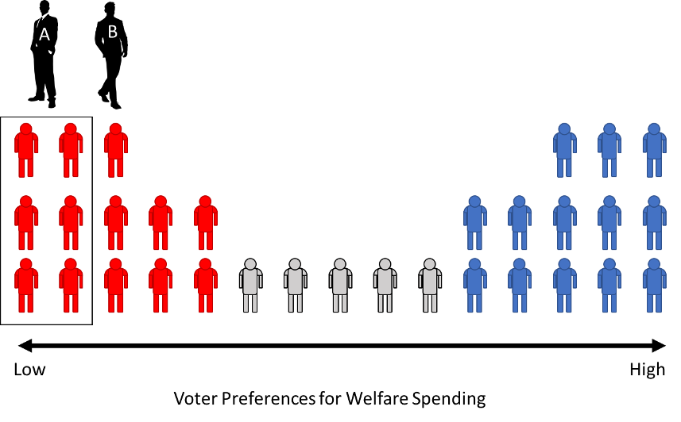
Seeing that he won’t be able to win the election, Candidate A leapfrogs his opponent and moves towards the center. Not to be outdone, Candidate B lurches in further toward the center until we end up with a situation as picture below where Candidates A and B are occupying middle ground that very few people actually find acceptable.
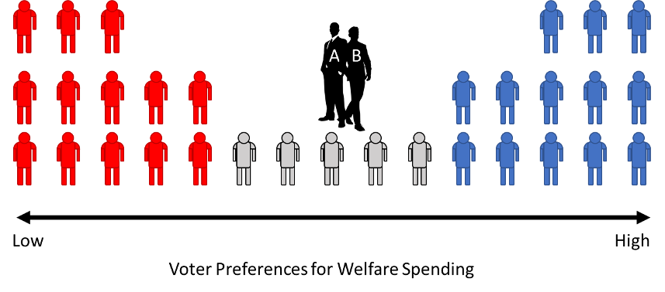

This scenario is so common that there is an accepted name for it: the median voter theorem. The mechanics of this behavior well models the real world situations that we often see where candidates pander to their base when needing the nomination (red or blue) but then head promptly to the center in the general election.
With these sorts of economic forces dictating voter preferences and politician responses on a number of issues, it is quite easy to see just why Arrow’s Impossibility Theorem comes into play as often as it does.

